# Guardians of the Dafeng - User Guide

## Table of Contents

* Getting Started
* Game Mechanics
* Controls
* Character Systems
* Tips for Beginners

## World Map

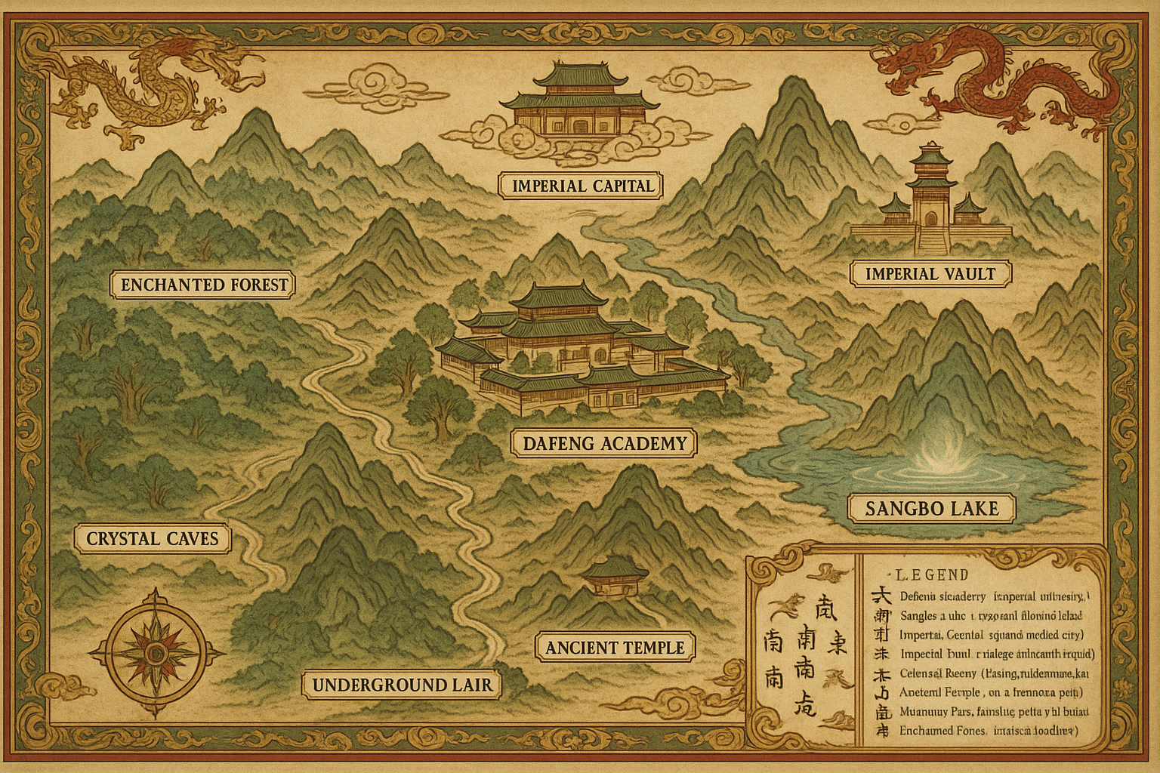

World Map

## Getting Started

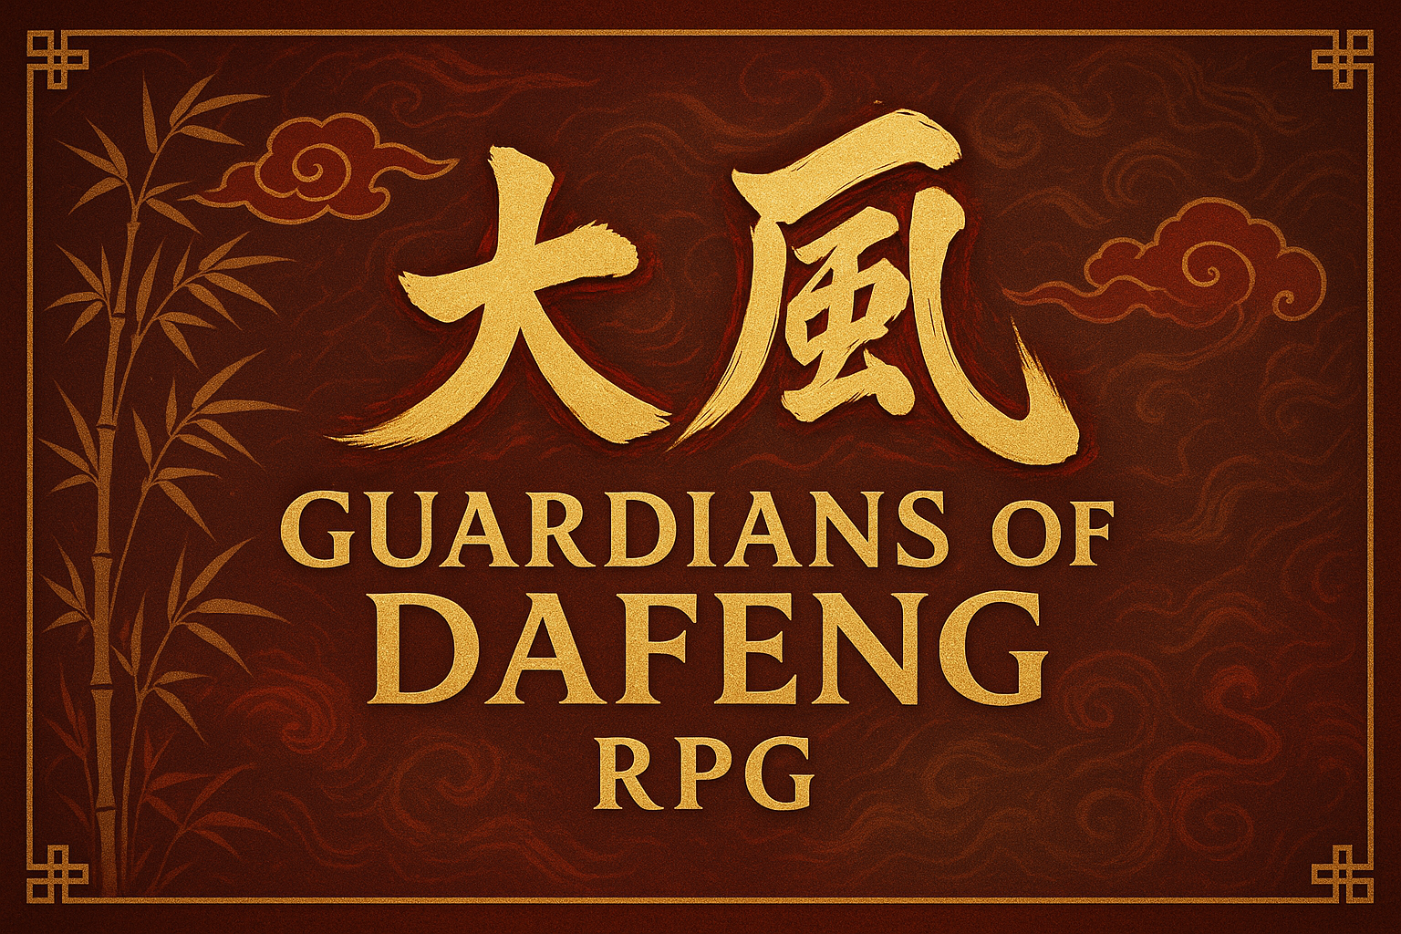

Game Title

### System Requirements

* **RPG Maker MZ Runtime**: Version 1.8.0 or later
* **Operating System**: Windows 10/11, macOS 10.15+, or Linux Ubuntu 18.04+
* **Memory**: 4 GB RAM minimum, 8 GB recommended
* **Storage**: 500 MB available space
* **Graphics**: DirectX 11 compatible graphics card

### Installation

1. Download the game files from the repository
2. Extract all files to your desired game directory
3. Run the executable file or open index.html in a web browser
4. Ensure all asset files are in the correct subdirectories

## Game Mechanics

### Investigation System

The Investigation system is core to solving mysteries and uncovering secrets.

**How to Use**: - Press **SPACE** near interactive objects to investigate - Look for visual cues like sparkles or highlighted areas - Some investigations require specific skill levels - Combine clues in your journal to solve puzzles

### Cultivation System

Develop your character’s spiritual and martial abilities through cultivation.

**Cultivation Types**: - **Physical Cultivation**: Enhances strength, speed, and endurance - **Spiritual Cultivation**: Improves magical abilities and energy capacity - **Mental Cultivation**: Increases wisdom, memory, and learning speed

### Faction Magic Systems

#### Confucian Arts

 *Master Chen, a wise Confucian master* **Philosophy**: Knowledge and righteousness as sources of power **Abilities**: - **Scholar’s Insight**: Reveal hidden knowledge and secrets - **Righteous Fury**: Damage increases when fighting evil enemies - **Protective Wisdom**: Create barriers using accumulated knowledge

#### Taoist Practices

**Philosophy**: Harmony with natural forces and balance **Abilities**: - **Elemental Mastery**: Control over fire, water, earth, air, and wood - **Yin-Yang Balance**: Switch between offensive and defensive stances - **Natural Healing**: Restore health using natural energy

#### Buddhist Powers

**Philosophy**: Compassion and enlightenment through suffering **Abilities**: - **Compassionate Healing**: Powerful healing abilities for self and others - **Karmic Justice**: Reflect damage back to attackers - **Enlightened Defense**: Immunity to mental attacks and illusions

#### Sorcery

**Philosophy**: Raw power through forbidden knowledge **Abilities**: - **Dark Magic**: Powerful offensive spells with health costs - **Soul Manipulation**: Control over spirits and undead creatures - **Forbidden Rituals**: High-risk, high-reward magical effects

## Controls

### Keyboard Controls

* **Arrow Keys / WASD**: Move character
* **ENTER / SPACE**: Interact / Confirm
* **ESC / X**: Cancel / Open menu
* **SHIFT**: Run (hold while moving)
* **CTRL**: Skip text / Fast forward
* **ALT**: Hide message window
* **F1**: Open help screen
* **F4**: Toggle fullscreen
* **F5**: Reload game
* **F12**: Open debug menu (if enabled)

### Gamepad Support

The game supports most standard gamepads: - **Left Stick / D-Pad**: Move character - **A Button (Xbox) / X Button (PlayStation)**: Interact / Confirm - **B Button (Xbox) / Circle Button (PlayStation)**: Cancel / Menu - **Y Button (Xbox) / Triangle Button (PlayStation)**: Open main menu

## Character Systems

 *Xu Qi’an, the protagonist*

### Character Stats

* **Level**: Overall character progression (1-50)
* **Health Points (HP)**: Character’s life force
* **Magic Points (MP)**: Energy for using special abilities
* **Cultivation Points (CP)**: Progress in spiritual development

### Primary Attributes

* **Strength**: Physical power and melee damage
* **Agility**: Speed, evasion, and critical hit chance
* **Intelligence**: Magical power and problem-solving ability
* **Wisdom**: Spiritual insight and cultivation speed
* **Charisma**: Social interactions and leadership

## Audio

### Background Music (BGM)

* **Theme01**: Main theme
* **Academy01**: Dafeng Academy
* **Lake01**: Sangbo Lake
* **Capital01**: Imperial Capital
* **Battle01**: Combat
* **Temple01**: Ancient Temple
* **Forest01**: Enchanted Forest
* **Cave01**: Crystal Caves
* **Victory01**: Victory Theme
* **Ending01**: Ending Credits

### Sound Effects (SE)

* **Cursor01**: Menu navigation
* **Decision01**: Menu confirmation
* **Cancel01**: Menu cancellation
* **Buzzer01**: Error
* **Coin01**: Gaining money
* **Item01**: Finding an item
* **Equip01**: Equipping gear
* **Save01**: Saving the game
* **Load01**: Loading a save
* **Bell01**: Temple bell
* **Sword01**: Sword attack
* **Magic01**: Casting a spell
* **Heal01**: Healing spell
* **Door01**: Opening a door
* **Chest01**: Opening a chest

## Tips for Beginners

### Character Development

1. **Choose Your Path Early**: Decide on Confucian, Taoist, Buddhist, or Sorcery focus
2. **Balance Your Stats**: Don’t neglect any attribute completely
3. **Practice Cultivation**: Regular meditation sessions improve all abilities
4. **Learn from Masters**: Seek out teachers for advanced techniques

### Quest Management

1. **Read Quest Descriptions**: They often contain important hints
2. **Check Your Journal**: Review objectives and collected clues regularly
3. **Don’t Rush**: Take time to explore and understand the story
4. **Save Often**: Create multiple save files for different story branches

## Quest Information

### Main Quest Overview

The game features **5 major storylines**:

1. **The Missing Scholar**: Academic mystery investigation
2. **The Sangbo Lake Mystery**: Supernatural phenomenon
3. **The Shadow in the Capital**: Political intrigue
4. **The Lost Heirloom**: Ancient artifact recovery
5. **The Celestial Tournament**: Martial arts competition

### Side Quest Categories

**12 additional quests** provide extra content:

* **Temple Cleansing**: Spiritual purification missions
* **Rescue Operations**: Saving people in danger
* **Curse Breaking**: Removing magical afflictions
* **Resource Gathering**: Collecting rare materials
* **Combat Challenges**: Testing martial prowess
* **Investigation Cases**: Solving local mysteries

**Game Version**: 2.5.0  
**Total Content**: 17 Quests, 10+ Hours of Gameplay